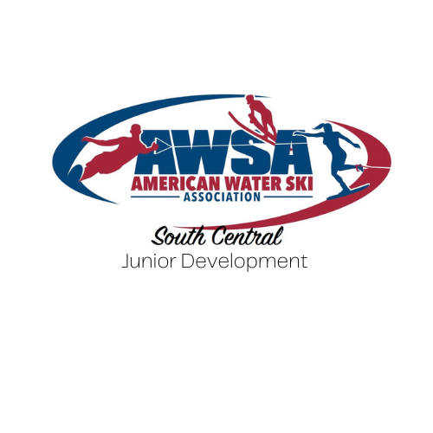

**2025 Sponsorship Opportunities**

Please help support the South Central Region Junior Development program. The goal of this program is to attract new junior skiers and families, promote junior skiers, and provide junior skiers with opportunities to improve their waterskiing skills. Donations will be used to host clinics and tournaments and award skiers for their achievements.

|  |  |  |  |  |
| --- | --- | --- | --- | --- |
|  | **GOLD $2500** | **SILVER $1000** | **BRONZE $500** | **SUPPORTING <$500** |
| Name/Logo on Jr. Development T-shirt |  |  |  |  |
| Name/Logo on Team Bibs |  |  |  |  |
| Name/Logo on Donor Banner at Regionals | Lrg logo/middle banner | Medium logo/perimeter of banner | Small logo/outside perimeter of banner |  |
| Social Media Newsletter Promotion |  |  |  |  |

NAME:_____________________________________

 GOLD $2500

 SILVER $1000

 BRONZE $500

 SUPPORTING less than $500

PHONE NUMBER:____________________________

EMAIL:_____________________________________

Please fill out sponsorship form and return to Lauren Malitz at [southcentralregionjd@gmail.com](mailto:southcentralregionjd@gmail.com). Payments may be made via cash, check, or Paypal.

*A donor contribution letter will be provided for tax purposes to email above.